Exercise: How to Write a Paragraph

In short:
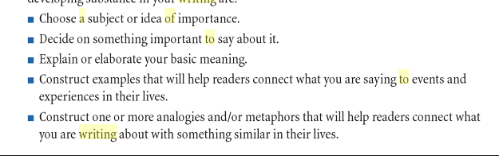

In Practice:

- Read and reread the selection, question, or prompt. Identify the task, what you are being asked to do. I
- dentify important ideas and implications in the text. These ideas may be embedded in the text or only implied, requiring you to extract the meaning. In English, these may be structural, symbolic, thematic, profound, etc.
- Express an important issue existing within the ideas you have identified.
- Decide on an important point to make about that issue.
  - This is your Thesis. If we cannot accurately state our key idea in a sentence, using our own words, we don’t really know what we want to say.

- Elaborate your thesis: (Explain) If we cannot elaborate our key idea, then we have not yet connected its meaning to other concepts than we understand.
- Exemplify your thesis: (Examples) If we cannot connect what we have elaborated with concrete situations in the real world, our knowledge of the meanings is still abstract and, to some extent, vague. Clarify.
- Illustrate your thesis: (another way to say it) If we cannot generate metaphors, analogies, etc. of the meanings we are constructing, we have not yet connected what we understand with other domains of knowledge and experience.

In some cases:
- It is helpful to formulate at least one objection to your position (antithesis)
- Respond to that objection (crediting any point in it that is worthy of concession).

