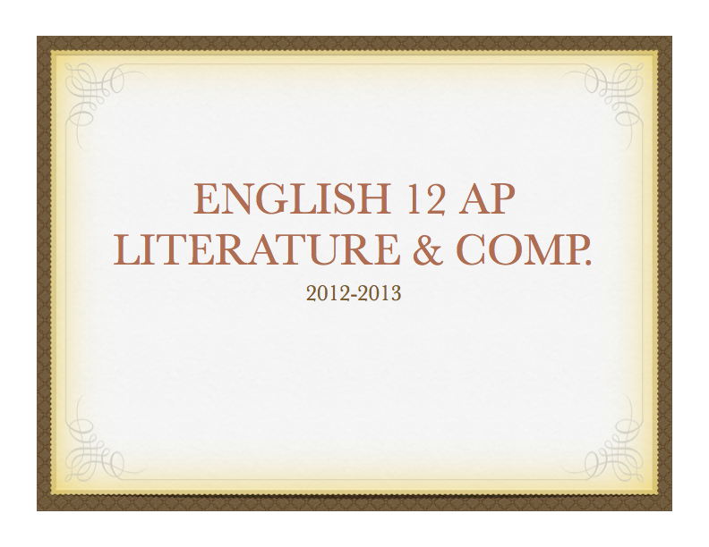
Course Philosophy:
Designed like a college course, in accordance with the College Board Course Description, AP English 12 is a discussion-oriented course, challenging the highly motivated college-bound student who has been successful in prior writing and literature courses. Students should already have a mastery of writing conventions and research skills. The course emphasizes independent work, leadership, class participation, creativity, and English academic excellence. Preparation for college writing and literature classes is achieved through intensive practice of expository and creative writing styles, including literary analysis. Students will be required to do extensive reading and critical analyses as well as tests in the same format as the AP English exams offered each May.
- Active participation is an expectation!
    - You must complete all of the reading and writing assigned and be willing to engage in maintaining a classroom dialogue responsibly--both as part of the class as a whole and within smaller groups. We cannot discuss what you have not read.
- No in-class reading or in-class research time should be expected. (Though we may do so on occasion.)
    - Literature poses intellectual challenges that do demand analysis, research, and referencing literary critiques. The literature of this course can and will be used to test our interpretations: anything said about a work should be supported by evidence from that work.
- "Keeping up" is crucial to understanding discussion.
    - We expect you to keep up- -which means to complete both assigned readings and your work on, or before, the dates due. Late work will be evaluated, but deducted for its lateness and receive few comments.

REQUIRED SUMMER READING
Literature is an expression of a society, that which they believe in and value, and is influenced by the collective history of that society. The following background readings are necessary to fully understand and appreciate Western Literature: (texts available from the library, or online e-texts at: gutenberg.org)
~Aristotle, Poetics (focus on requirements for a tragic hero and the parts of a tragedy)
~Plato, The Republic (emphasis on the nature of art and truth, focus on the analogy of The Cave)
~Mythology Review: Mythology (Recommended: Hamilton OR Bullfinch), or another comprehensive anthology of myths. (be familiar with Babylonian, Greek, Roman, and Norse gods, heroes, myths, and great families)
* You need to be able to apply these concepts and recognize allusions to them. Assignments may require you to use what you learned in these works without further discussion on them prior to your referencing them in your work.

IT IS ALSO ADVISABLE THAT YOU READ:
~Works from the AP Book List and the Reading List for College Bound Students you have not yet read.
~ Gilgamesh and the Iliad if you have not read the full text and only experienced excerpts.
~Arthurian Legends: preferred- Le Morte d’Arthur (Mallory) OR King Arthur and His Knights (Steinbeck)
~The Bible: Genesis, Psalms, Matthew, Mark, Luke, John, Revelation and Stories of Old Testament heroes (Unless it is your religious tradition you need not read the actual Bible, a book of Biblical annotations and/or allusions, or The Idiot’s Guide to the Bible will do).
**The Bible is the basis for Western morals and philosophy, and is frequently alluded to in literature. The purpose of assigning readings from The Bible is to familiarize students with these influences, NOT to promote the Christian religion (to educate, not indoctrinate).
SAMPLE READING SYLLABUS
(there will be other readings in addition to this list for 2014-2015)
- An Introduction to Fiction, Poetry, and Drama (course text)
- Beowulf
- Inferno
- Canterbury Tales
- Dr. Faustus
- Hamlet
- Paradise Lost
- Modest Proposal
- Faust, Part I
- Pride & Prejudice
- Frankenstein
- Modern novels
- Poetry for each era
- Literary Criticism
- Workplace Documents
- AP Prep.

GRADE SCALE
30% Assignments
40% Essays (100 pts ea. w/rewrite opportunity)
10% Term Paper (Fall), AP Exam (spring)
15% Participation
5% Tests/Quiz/Final

Grades:
A+ = 97-100
A = 93-96
A- = 90 - 92
B+= 87- 89
B = 83 - 86
B- = 80 - 82
C+=77-79
C=73-76
C-=70-72
D+= 67-69
D =63-66
D- = 60 - 62
Literature helps us to make contact with history (with history made and in the making), to recognize that "old" emotions are still valid, and that the questions that count are the unanswerable ones, the ones we for which we live.
What this course will try to do is provide you with some of these experiences by having you read and respond to a selection of works representing classical English literature, as well as a variety of other selections. For most readers, grappling with these challenges enhances the pleasure of literature. By studying literature, you "see" more of it to appreciate. You learn that, far from being remote from life, good literature pleases you by reflecting and giving order to life.

